Article 10 — The Policy Problem
Michal Doroszewski
You’re trying to make a simple change. Nothing dramatic — just updating a setting that should take five seconds. You open the portal. It tells you the setting is controlled by policy. You open the policy. It tells you the setting is controlled by another policy. You open that policy. It tells you the setting is “Not configured,” which somehow still means “No.”
You check the documentation. It says the behavior depends on “context.” You check the context. It says the behavior depends on “policy.” You check the policy again. It says the behavior is “By design.”
You haven’t changed. The requirement hasn’t changed. The system hasn’t changed. The only thing that changed was your belief that policy was a tool instead of a maze.
That is the Policy Problem. Not the “bad rule” kind — the architectural kind. The kind that appears when cloud systems are governed by layers of inherited, overlapping, and contradictory policies that were written for environments that no longer exist. The kind that makes modernization feel like archaeology.
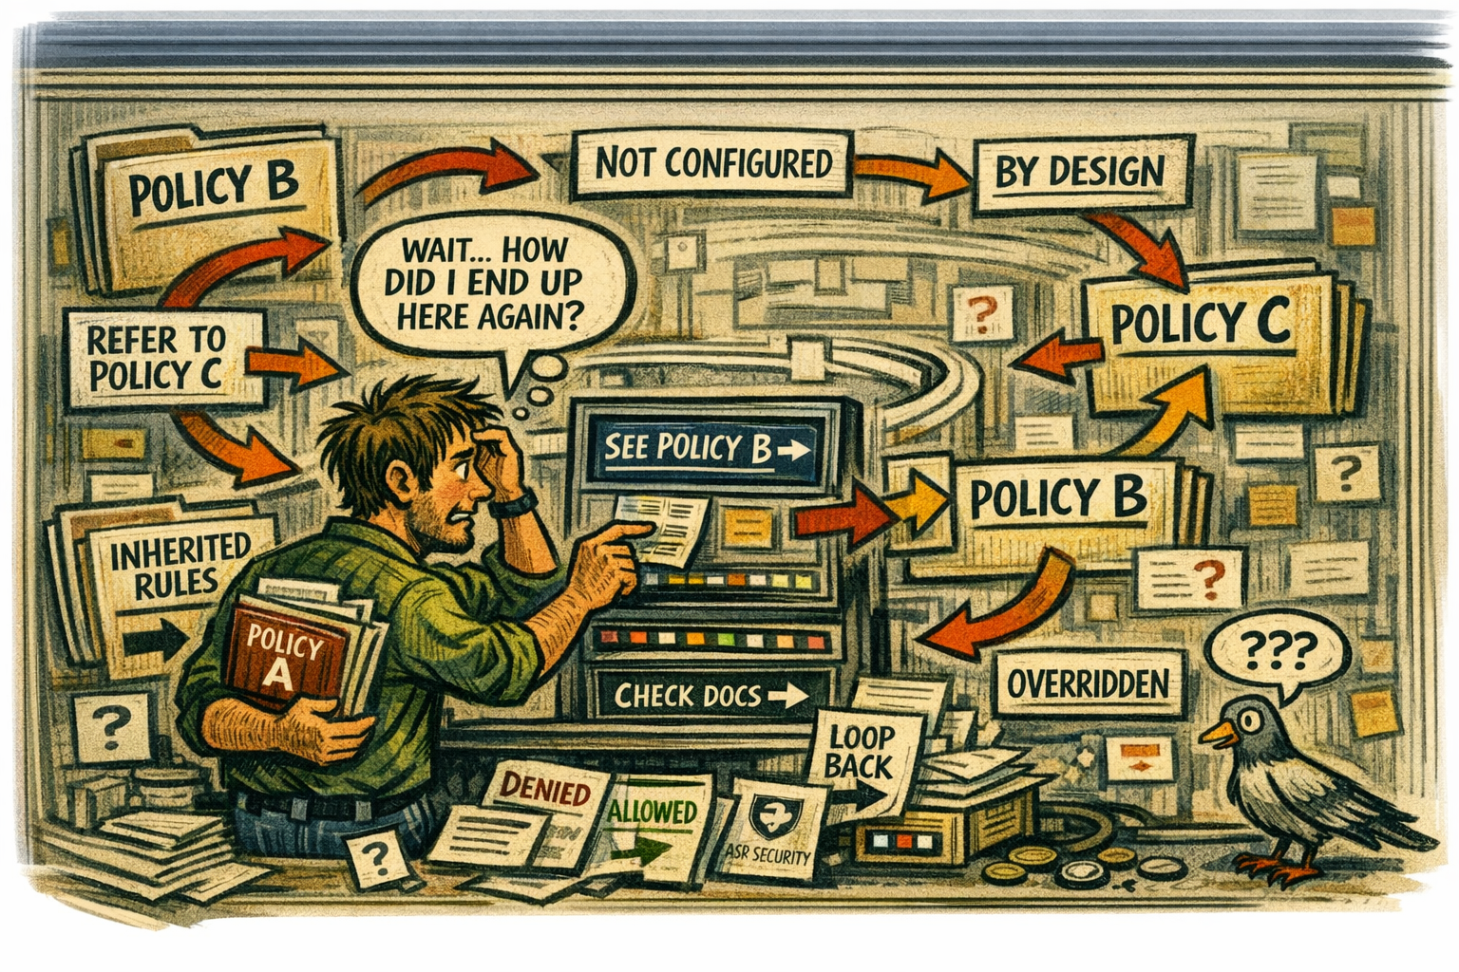
How Policy Became the Shadow Architecture
Policy is supposed to express intent. In modern cloud systems, it expresses architecture.
Every setting, every control, every behavior is shaped by policy. Conditional Access, device trust, session lifetime, media routing, region selection — all of it is governed by rules. Policy is the invisible scaffolding that determines what the system can do, what it must do, and what it refuses to do.
In Commercial environments, policy aligns with architecture. In GCC‑Moderate, policy collides with it.
Why GCC‑Moderate Turns Policy Into a Constraint
The FedRAMP Moderate boundary predates modern cloud policy. It was designed for static controls, not dynamic enforcement. As a result, many policies that work in Commercial behave unpredictably in GCC‑Moderate.
Some policies silently downgrade.
Some policies silently override.
Some policies silently conflict.
Some policies silently do nothing.
The system isn’t ignoring policy. It’s reconciling it with an architecture that cannot support the intent.
Policy is not failing. It is compensating.
Why Headquarters and Field Offices Experience Policy Differently
Headquarters sits close to identity controllers, cloud egress, and stable paths. Policies behave as expected. Field offices sit behind WAN optimizers, MPLS circuits, and inspection layers. Policies behave like riddles.
A Conditional Access rule that works in headquarters denies users in field offices.
A device compliance policy that evaluates instantly in headquarters times out in the field.
A session lifetime policy that behaves predictably in headquarters resets unexpectedly elsewhere.
The architecture creates two realities — one where policy is law, and one where policy is suggestion.
Why Policy Conflicts Are Misdiagnosed
When policy behaves unpredictably, teams look for culprits. Security blames configuration. Identity blames precedence. Network blames routing. Cloud blames inheritance. Users blame the universe.
Everyone is correct. Everyone is wrong.
The failure is architectural.
The boundary blocks the signals policy depends on.
The WAN distorts the timing policy requires.
The region model misleads the context policy evaluates.
The telemetry is missing, so the system cannot explain its decisions.
Policy isn’t broken. It’s interpreting partial truth.
Why Modernization Efforts Stall When Policy Collides With Architecture
Modernization depends on clarity. Policy depends on clarity. Architecture in GCC‑Moderate provides neither.
A policy that improves security breaks access.
A policy that improves access breaks compliance.
A policy that improves performance breaks trust.
A policy that works in testing collapses in production.
Leadership sees conflicting reports that are all true but incomplete.
Teams argue over symptoms instead of causes.
Users experience inconsistency instead of stability.
This is not dysfunction. It is policy operating inside an architecture that cannot support its intent.
The Root of the Policy Problem
The policy problem is not caused by misconfiguration, lack of expertise, or poor governance. It is caused by an architecture that predates dynamic policy enforcement.
The boundary hides context.
The WAN distorts timing.
The region model misleads evaluation.
The telemetry is missing.
The policy engine receives partial truth.
You cannot enforce policy without visibility.
You cannot evaluate context without continuity.
You cannot modernize governance inside a maze.
You cannot align intent with behavior when the architecture disagrees.
The Only Way Forward
Policy must be allowed to reflect reality.
The boundary must allow the signals policy depends on.
Telemetry must be restored.
Context must be accurate.
Timing must be reliable.
Region awareness must be correct.
Session continuity must be visible.
Only then can policy behave the way it was designed to behave.
Only then can governance become predictable.
Only then can modernization move forward without contradiction.
Only then can architecture and policy finally agree.
About the Author
Michal Doroszewski
Michal Doroszewski is a technology strategist focused on cloud architecture, identity platforms, and federal modernization. He writes about the structural and architectural forces that shape government IT, translating complex technical constraints into clear, accessible narratives for leaders and practitioners.

